# Insider Trading Bank Application Local Setup

The purpose of this project was to develop a web application that would integrate fido2 authentication using a Yubikey. We decided on a bank because security is important for any financial application. Listed below are the set-up instructions on how to get this web application up and running on your local machine using IntelliJ, Tomcat, and MongoDB. These specific instructions are for a Windows operating system, but the steps are similar for Mac and Linux.

# Make Sure Java is Installed

For this project we used jkd11, as it integrated best with our other tools. There are two different options on where you can download jdk11.

* 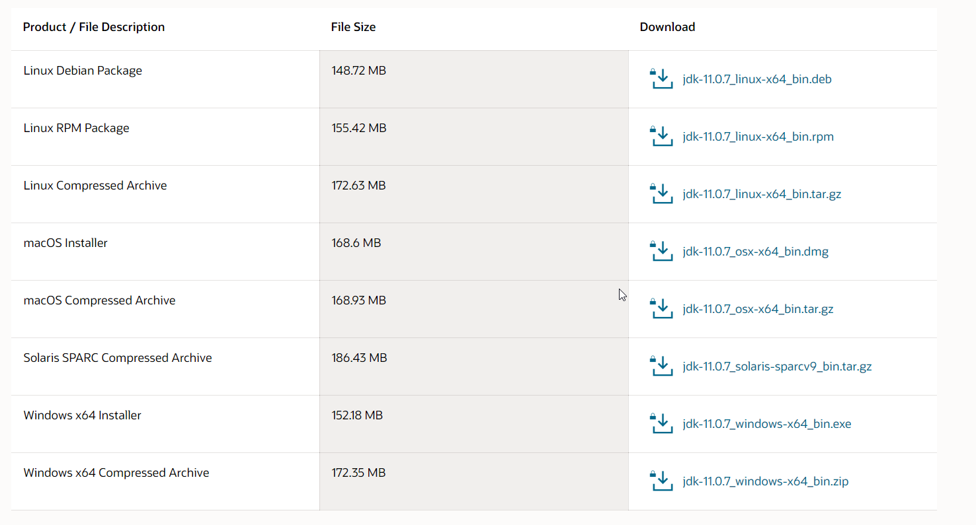<https://www.oracle.com/java/technologies/javase-jdk11-downloads.html>
* <https://adoptopenjdk.net/archive.html?variant=openjdk11&jvmVariant=hotspot>

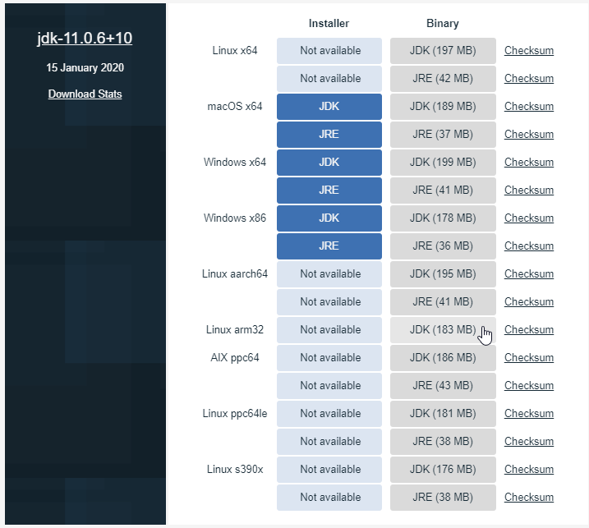

There were issues when multiple different jdks were installed, so if you run into an error try uninstalling all other versions of Java.

# Edit System Environment Variables

To ensure all other application are pointing to the correct Java version you might have to edit you System Environment Variables.

* Open windows search and type “system environment variables”

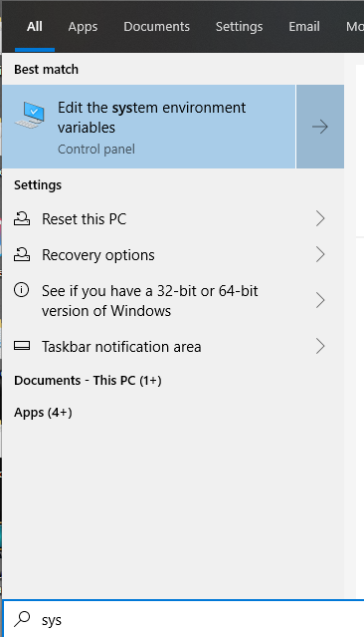

* Click Environment Variables

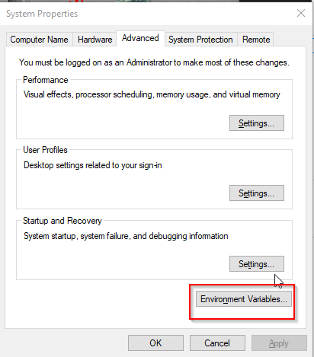

* Select JAVA_HOME and click Edit

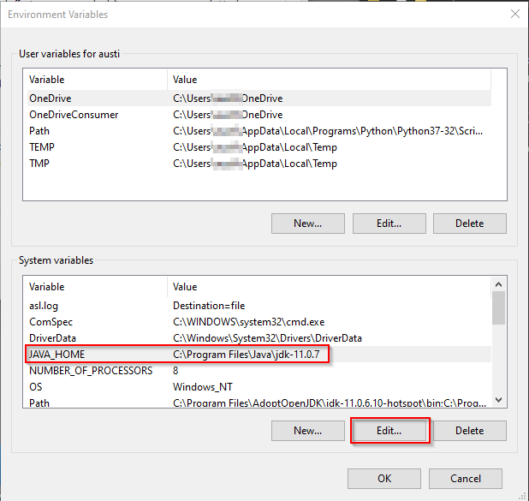

* Click Browse Directory, and find where on your computer Java is located, and the path is correct under variable value. If you do not see JAVA_HOME, click New… to add it.

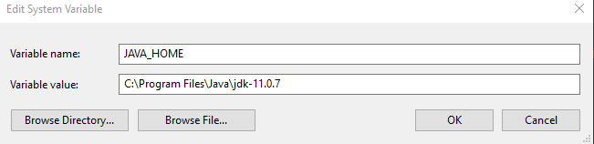

# Clone the Repository

In order to start working on your own copy of the application you will need to go to the URL listed below, and click the fork button. From there you will have your own local repository, and are free to do whatever you want with it.

* <https://github.com/ezekielnewren/insidertrading>

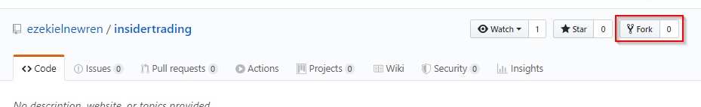

# Install Apache Tomcat

The server application we chose to run was Apache Tomcat, it runs on Java and works with IntelliJ. We used version 9.0. At the time of documentation, the most recent version is 9.0.34.

* <https://tomcat.apache.org/download-90.cgi>

In order to avoid Windows security issues, we found it was best to download the zip folder and extract it into the C:\Users\(user) folder.

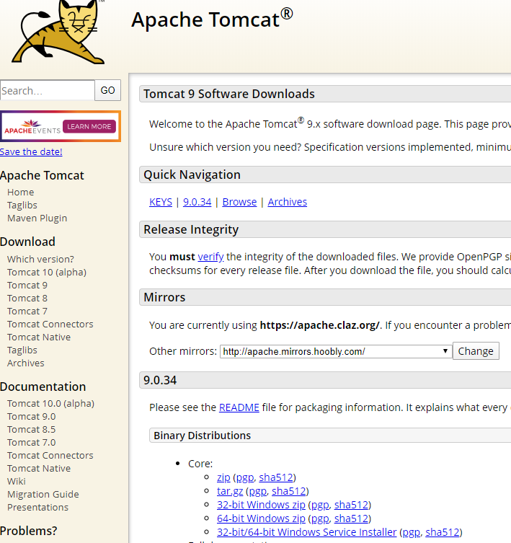

# Install IntelliJ IDEA

We decided to use IntelliJ IDEA to write the application as it was available for free for Weber State Students. All following instructions are for IntelliJ specifically, if you are using a different IDE, I guess you are on your own. We used IntelliJ IDEA 2019, at the time of documentation we didn’t upgrade to 2020 because it didn’t fully support some plugins.

* <https://www.jetbrains.com/idea/>

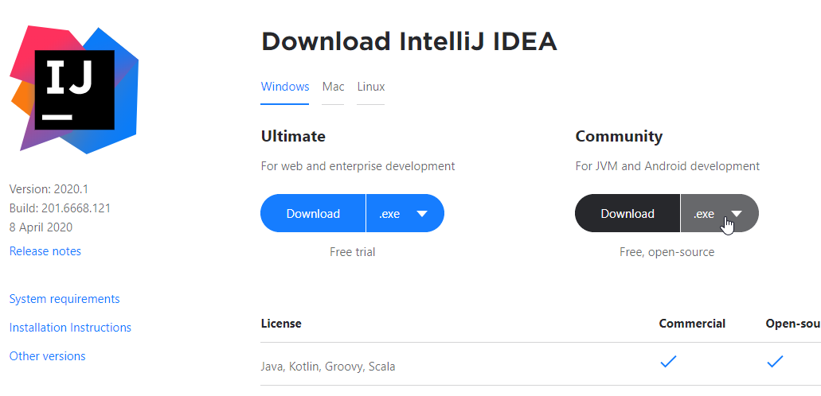

# IntelliJ Settings

First, install the Lombok plugin for IntelliJ. Click on setting, Plugins, search for Lombok and Install.

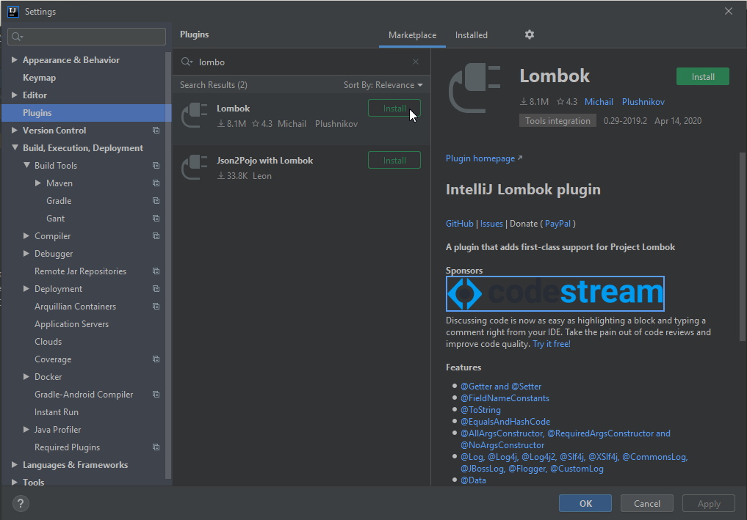

Make sure IntelliJ is pointing toward JDK11.

* Click on File – Project Structure.

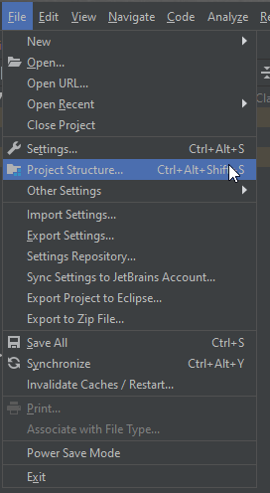

* Then select SDKs, click the + sign, and select JDK.

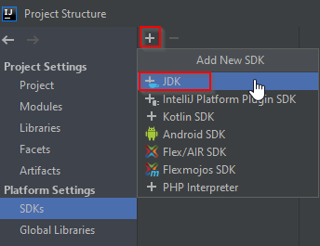

* Finally, navigate to where Java is located on your computer and select jdk-11

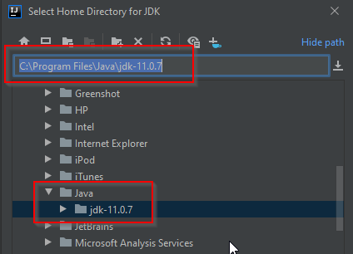

# Run Gradle Build

On the right side of your IntelliJ window there is a button for Gradle. Click that button, expand the Task folder, then the build folder. Finally click build and wait for the project to build.

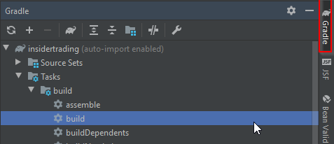

If there are errors, you might have to make sure Gradle is also pointing at the correct JDK, or you might have to delete a previously built war file. You can find that file on the project manager window under the libs folder, which is found under the build folder.

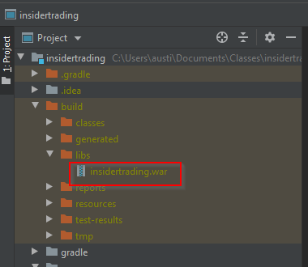

# IntelliJ - Tomcat Run Configuration.

To get IntelliJ to run the program and launch Tomcat, you will need to edit the Run Configurations. Located at the top right of the window there will be a dropdown located to the left of the green play button. Expand the dropdown and select Edit Configurations.

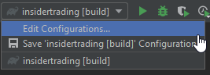

Next, you will click the + button located at the top left of the new window. From there you will find Tomcat server, then Local. You might have to expand the options to find it.

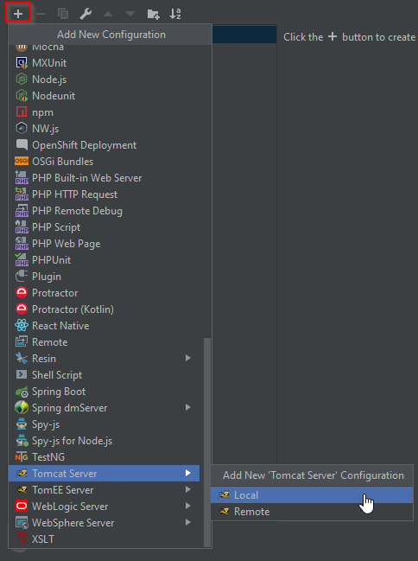

From there you will click the configure button, open the folder, and point it to where you have Tomcat stored. Then you will change the URL to http://localhost:8080/insidertrading. You can also deselect the “After launch” option, so that IntelliJ does not automatically open your browser every time you run the project.

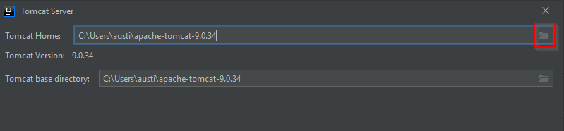

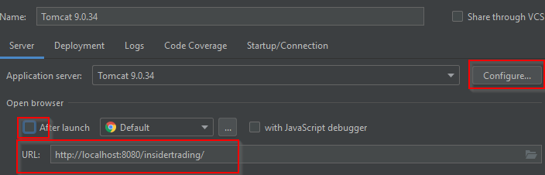

At the bottom of the window you will click the + button located under the “Before launch” section. You will then select Build Artifacts.

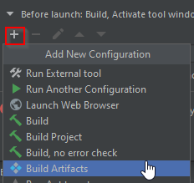

Select “Gradle: com.ezekielnewren: insidertrading.war” and click OK.

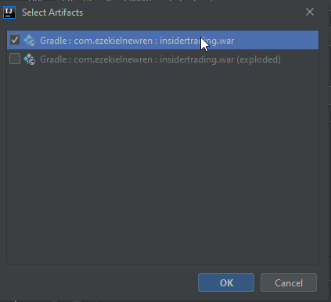

Next, select the Deployment tab, click the + button, and select Artifact.

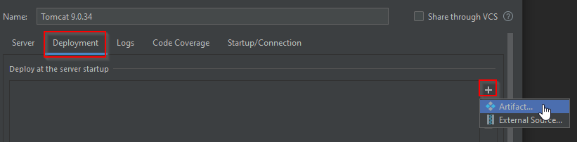

Select “Gradle : com.ezekielnewren : insidertrading.war” and click OK.

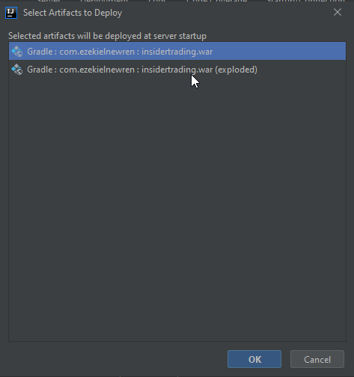

Finally, change the Application context at the bottom of the window from /Gradle___com_ezekielnewren___insidertrading_war to /insidertrading.

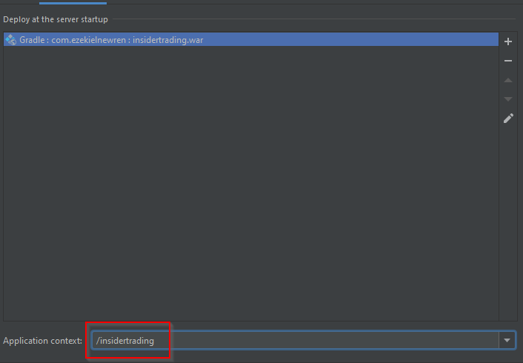

# Edit Tomcat to Allow HTTPS

Open File Explorer, and navigate to where ever you have Tomcat installed. Click on it, and then open the conf folder. Inside the conf folder open server.xml with your text editor of choice.

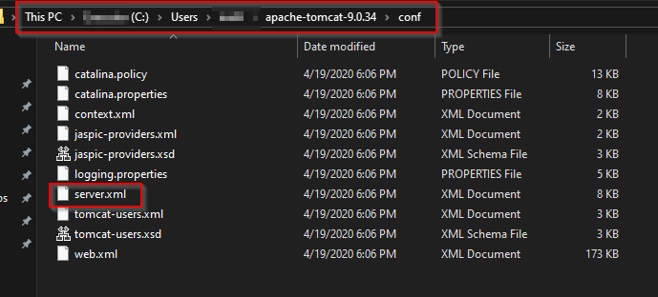

Within servel.xml, add the following text after <Service name=”Catalina”> and bellow the section <Connector port=”8080”…/> and save the file.

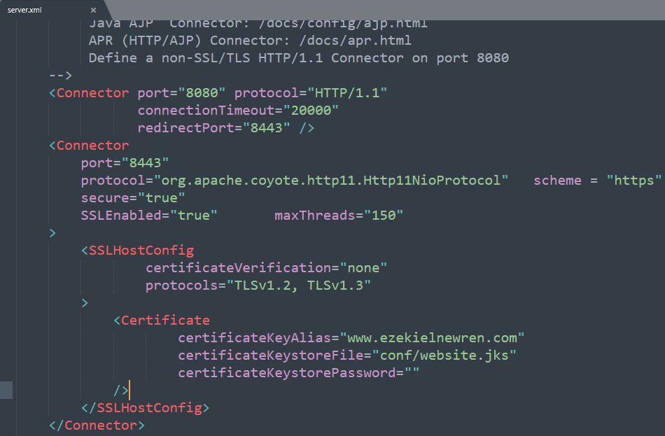

<Connector

port="8443"

protocol="org.apache.coyote.http11.Http11NioProtocol" scheme = "https"

secure="true"

SSLEnabled="true" maxThreads="150"

>

<SSLHostConfig

certificateVerification="none"

protocols="TLSv1.2, TLSv1.3"

>

<Certificate

certificateKeyAlias="www.ezekielnewren.com"

certificateKeystoreFile="conf/website.jks"

certificateKeystorePassword=""

/>

</SSLHostConfig>

</Connector>

# Create a KeyStore in Tomcat

To enable https within Tomcat you will need to create a local KeyStore. We chose to use KeyStore explorer, which you can download at this URL.

* <https://keystore-explorer.org/>

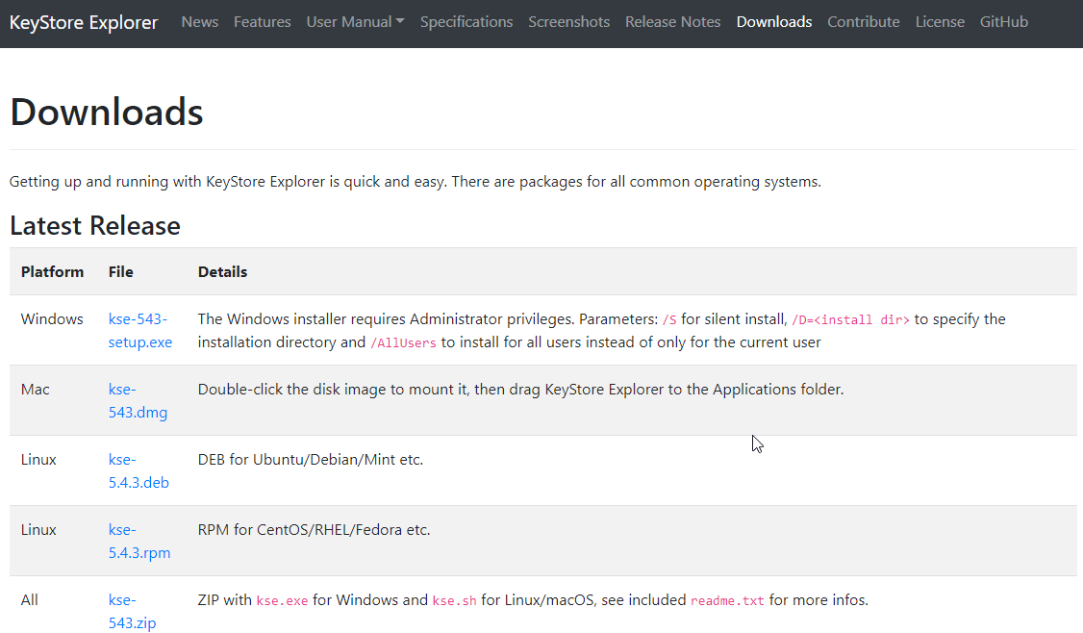

After KeyStore Explorer is installed click Create a new KeyStore, make sure JKS is selected, and click OK.

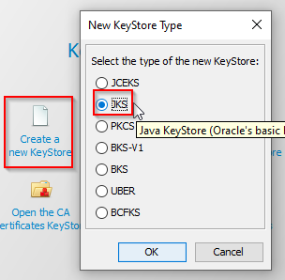

On the application toolbar select the button that looks like two keys with a green + sign to generate a key par. Then make sure RSA is selected and click OK.

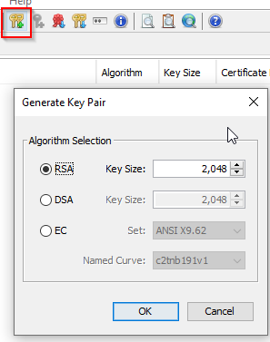

After clicking okay, select the button that looks like a tan book with an @ sign in the middle.

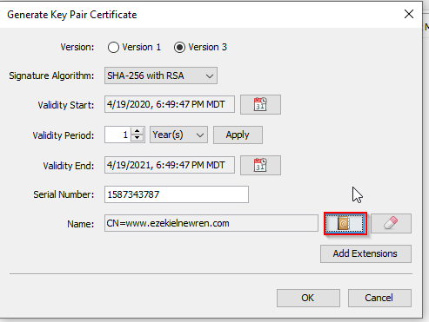

On the new window, under Common Name enter the text www.ezekielnewren.com, and click OK.

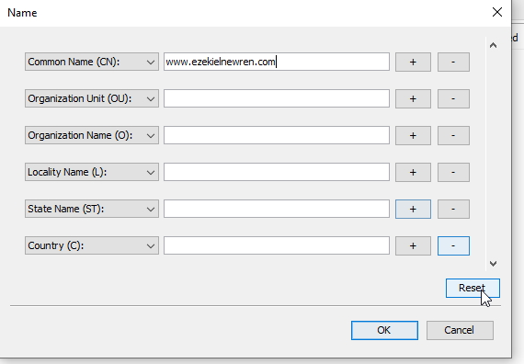

Back on the Generate Key Pair Certificate make sure under name is shows CN=www.ezekielnewren.com and click OK. On the New Key Pair Entry Alias window confirm the Enter Alias field is www.ezekielnewren.com and click OK.

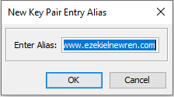

On the New Key Pair Entry Password window leave both password fields blank and click OK.

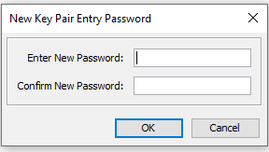

With the new KeyStore selected, click File, Save as. Then make sure you save the KeyStore under the conf folder under you Tomcat file. The same location where we edited server.xml. Save it as website.jks.

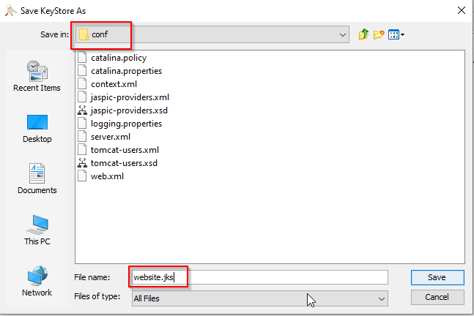

# MongoDB

We used MongoDB as our database, as it is very user friendly and free. You can download MongoDB at the URL below.

* <https://www.mongodb.com/download-center/community>

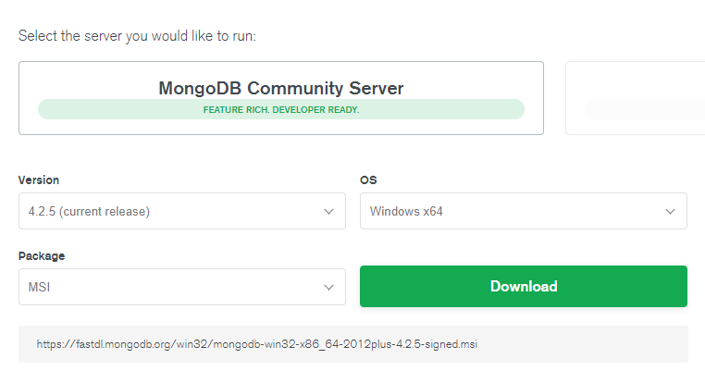

# Edit the Hosts File

To ensure that your web browser navigates to your Tomcat instance you will need to edit your systems hosts file. Search for Notepad, right click and Run as administrator.

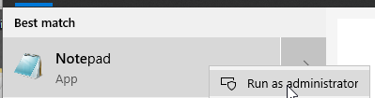

Click File, the Open, and navigate to C:\Windows\System32\drivers\etc. Once there change the dropdown from .txt to include all files, and select hosts.

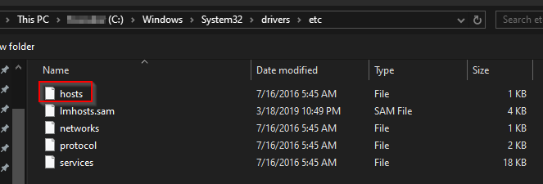

Within your hosts file create a new line on the bottom and type in (tab) 127.0.0.1 (tab) www.ezekielnewren.com and save your hosts file. The # symbols are used to comment out a line. So if you ever get the application running on a remote server, you will need to comment this line out to make it work.

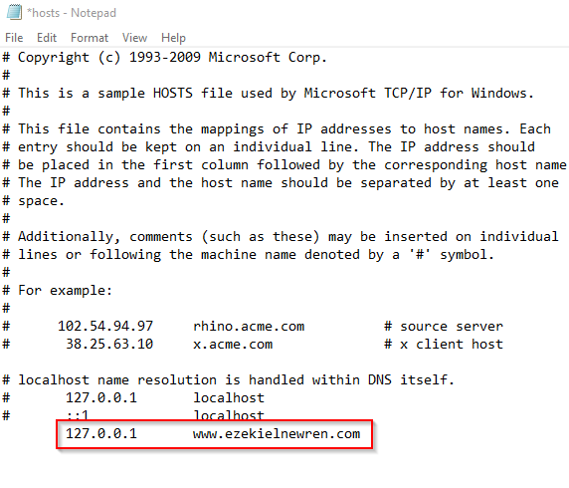

# Running the Application

Now that all the setup is complete you can run the application. On IntelliJ, make sure Tomcat is selected and click the green play button.



Wait for the artifacts to be deployed and then open your web browser of choice and navigate to https://www.ezekielnewren.com:8443/insidertrading. If everything was done correctly you will see the login screen, and everything should be good to go.

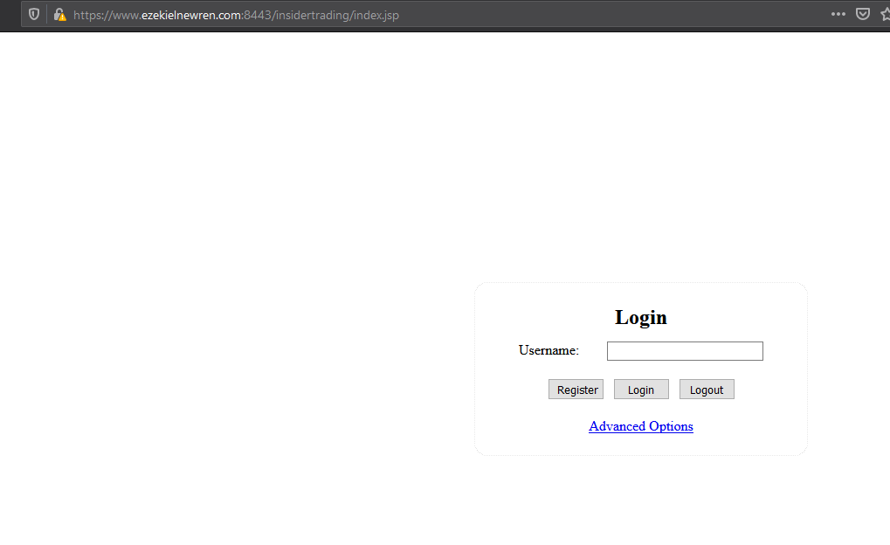

# Making the Project Your Own

If you decide you want to add on to this application there are a few additional steps you will need to take. First, sign up for a linux server on your hosting platform of choice, and choose a **unique URL.** Do not use www.ezekielnewren.com, use something like www.insidertradingbank.com. Then you will need to make a few additional changes to your files and code.

Open IntelliJ and open the build.gradle file. From there navigate to the createProperties method and find where it says p['fqdn'] = "www.ezekielnewren.com", and change that to the new URL.

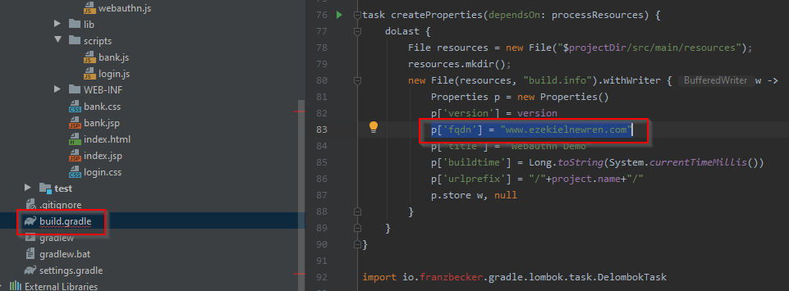

Then all instances where you had previously entered www.ezekielnewren.com will need to be changed. This includes the server.xml file, the common name and alias on your keystore.jks, your hosts file, and finally the URL you visit at the end.

Good Luck!